1. 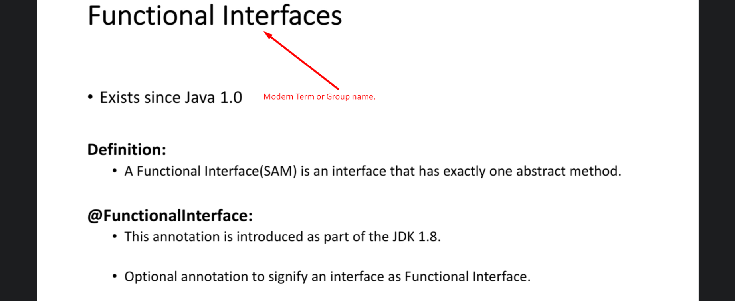
2. 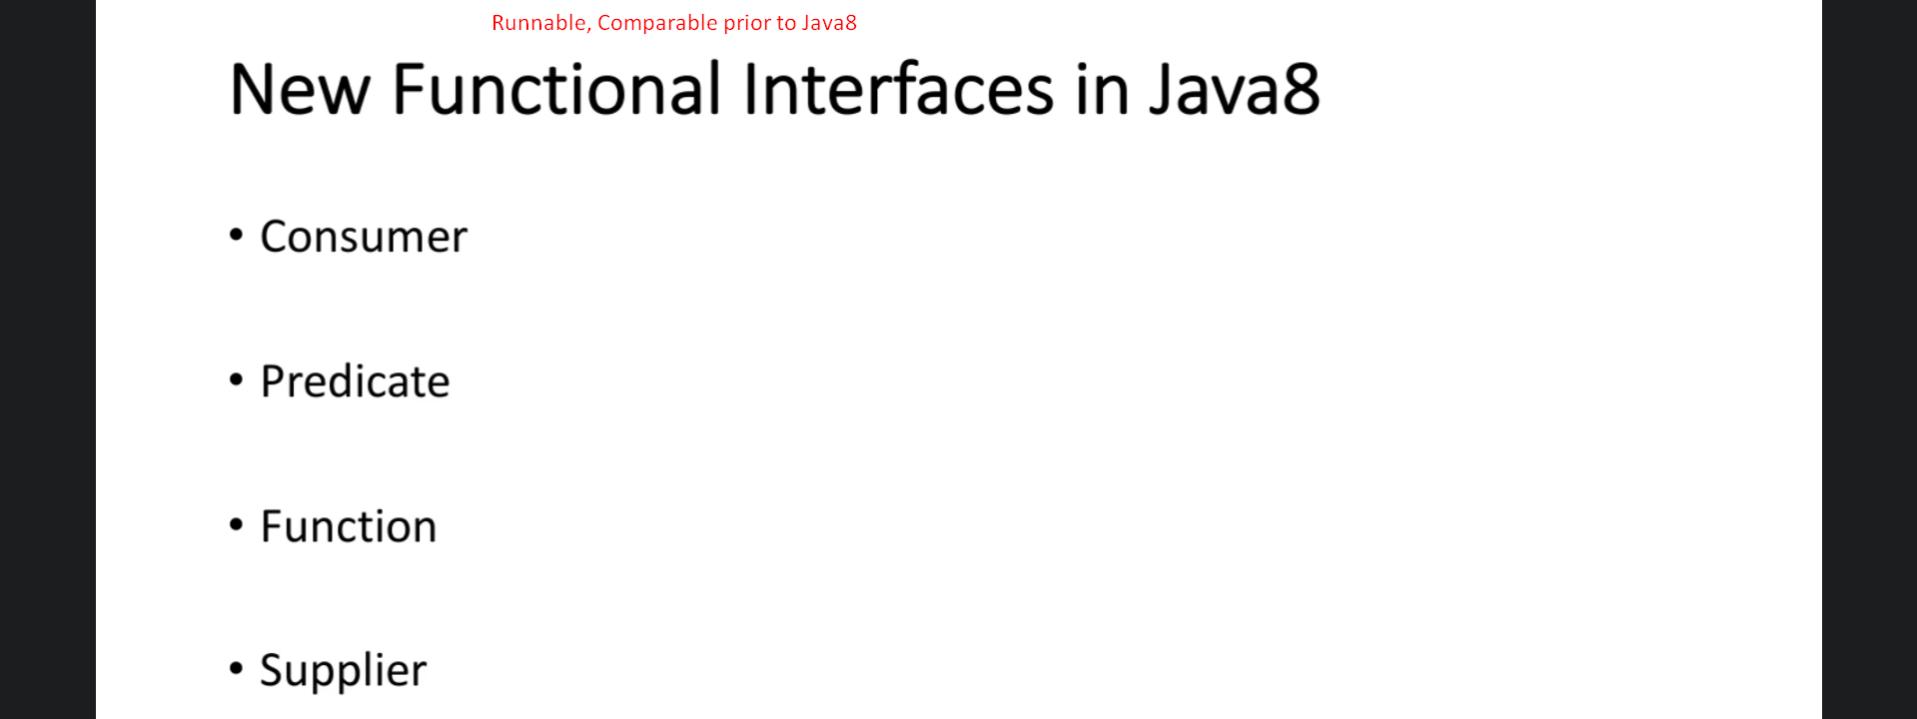
3. 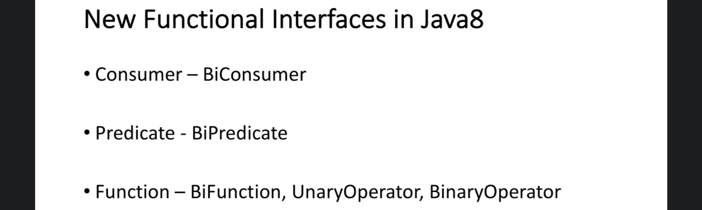
   1. You may ask that we didn’t use any of these interfaces still my app is working like a charm.
   2. Why do we have to learn these interfaces?
   3. There are a lot of enhancements to Collection Framework (List, Map etc) that is going to make your life much easier.